August 1, 2024
Work to review
- Customer Survey
- RFQ Message for Vendor

Meeting Notes To Review With SPK
- Discuss the Web To Lead Form
- Discuss Cepheid
- Discuss PPSA, ADL, CSP acronyms not appearing on reports
- Need more information on what we want done - ALL PRINT TEMPLATES
  - Shipping list info date is appearing as shipping list date
- RFQ Print Template
  - Which notes need to appear in the box on the report - vendor notes or customer notes
- CC’ing and having the names auto populate - wanting to have internal team names populate - should we select this from a list or how should we approach this?
- Discuss how we want to approach items in a kit being taxable and non taxable - will need to have 2 different items part of the kit

- RFQ Reminders - once the RFQ is confirmed IF the rep does not have access to create the estimates (User Preference) (Hold Off for now)
  - Have a show message appear when the checkbox is clicked to send a notification to Veronica and other people in the future
  - User needs the ability to add the margin and additional notes which will be included on the email
  - Email will get sent with a link to the RFQ for Veronica to invoice
    - Veronica will send example
  - **Can be more than 1 RFQ per opportunity

- How to print a WIP report
  - Discussed
- Overdue Invoice App Routine
  - Updated the email that is sent out to include the amounts that are owed on the invoices
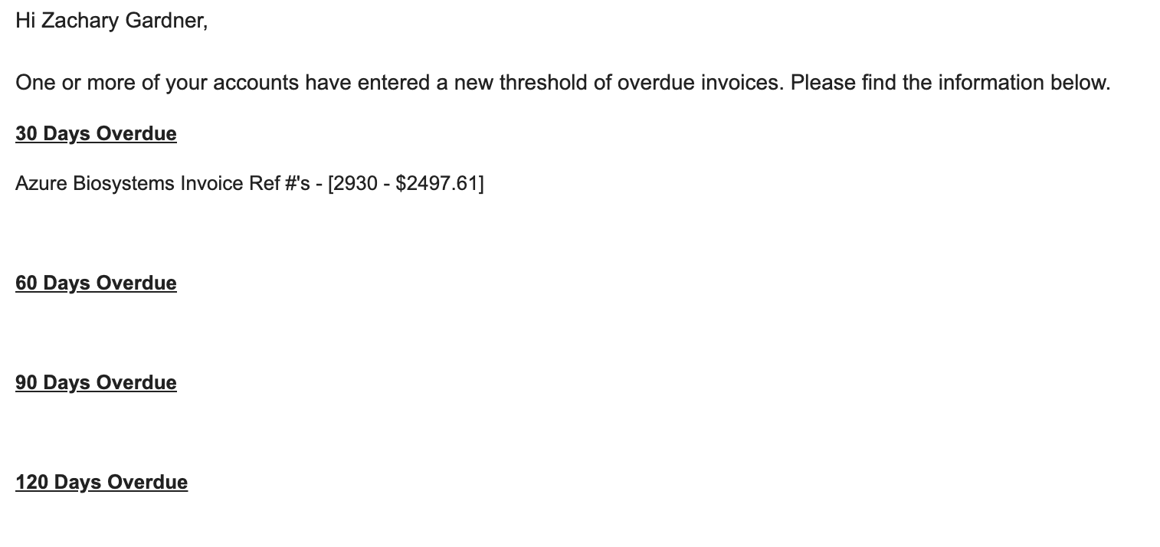

Meeting Discussion Notes (New)
- Customer Survey
  - Update the section with the defects to ask a question if they did encounter any problems and defects and if so how did we handle them
  - How likely are you to recommend SPKAssociates (Update Verbiage)
  - Send automatically once an order has been invoiced - Opportunity Status = Invoiced
  - Add rep to be viewable on the survey list screen
  - Have a notification sent to internal teams when it is submitted
    - Rep + Don + Veronica
      - Survey admins

- RFQ → Estimate
  - Some users are not able to create estimates - add in another preference for not being able to send estimates
  - This includes printing and sending
  - Give the ability to preview it
    - Either a watermark or not being able to download it whichever method is capable of
  - Button to Send for internal confirmation
    - Email will be sent to Veronica or other user in the future and then this will be emailed
  - Not able to create SOs or anything only save and preview

- Discuss the expediting process and how it is working this far (EXPEDITING PROCESS)
  - For the internal email
    - Change to include the shipped items similar to the customer template. - include the shipped date and add the PO# to be visible on the email as well
    - Include the ability to view the activity if need be

- Look into WIP Report to see what it is printing

- PPSA, ADL, CSP acronyms not appearing on reports
  - Add to all print templates that include key dates

- Ship List date instead of shipping list info date
  - Change of verbiage within method

- RFQ Special instructions
  - Add this to the print template above the scope of work and highlight yellow

- Activity updates
  - Remove expediting process and social media
  - Ability to deleted - refer to notes from last month

August 2, 2024
Offline Work
- RFQ Print Template - overlap issue
  - Updated spacing of the fields that were overlapping and updated don on the fix
- Responded to some emails from Don regarding activity that is created when the WTL for is filled and how to communicate with his customers in the portal.
- Documented tasks to be completed and the steps on how to complete them for new estimate email permissions and Expediting process
- WIP Report - Report App
  - Looked into the WIP report to understand what it was generating as values looked off. This was previously built to show all projects where an invoice was created but there was a balance that still remained - this did not account for SOs that have been created but not invoiced
  - Updated the logic such that if the SO is created they will appear as a project on the WIP Report
    - Updated don on the changes

August 6, 2024
Offline Work
- WIP Report
  - Created new WIP report template which includes information from estimates as well since these are open projects
    - Opportunities - Sales Orders, POs, Estimates
      - Updated Reports screen to function with this report
        - The projects that will print on the report are ones where either an SO has been created and invoice not paid OR where estimate has been created (not yet SO) and the estimate was accepted
        - This report will also represent the total amount of estimates that have not yet been converted further as a separate total from SOs that were already created
    - ***Need to update Estimates from past orders to be marked as accepted IF the sales order was converted from that estimate
August 7, 2024
Offline Work
- Reports
  - Updated status of all estimates that were converted to sales orders based on the SO memo to be accepted.
  - Added in a new total to appear within the report which is a sum of all estimates appearing regardless of if they have been accepted or not
  - Sent the report to Don to review and explained what all total amounts relate to

- Estimate Changes
  - Updated the default email template that has Amount - change to Total Cost
  - Updated the estimate print template to have a line break in between key dates and SOW

- RFQ Potential Update
  - Adding in new item image to the respective lines. Does this also need to be on the print template
  - Asked Don for more information

- New/Edit RFQ Changes
  - Updated the old grids on this screen to the new editable grid to refresh the screen feel and align with other method screens in addition to making everything align

August 8, 2024
Offline Work
- RFQ Print Template
  - Added in the special instructions field to be visible above the scope of work - this will only show if it is not empty and this information is highlighted in yellow
- Activity Reports Screen
  - Added in new activity type filter which would allow users to hone in on specific activity types.
    - Changing the type will allow users to look at how many of each type has been worked upon in relation to customer and vendors as requested by Don

Meeting Notes
- Reports
  - WIP Report
    - Discussed report further and information needs to be updated internally for the report to generate correctly
    - ALL accepted estimates need to be converted to sales order and this should clean the information up
  - Open Sales Order Report
    - Give the ability to select specific customers when printing this
    - Show customer PO#s
- Activity Reports
  - Update the printed reports to be based on the selections from the view filter
- RFQ Item Images

August 14, 2024
Offline Work
- Reports
  - Updated WIP report verbiage for totals - total WIP and total COGS vs SO and PO totals
  - Updated the report screen to allow users to print a WIP with Estimates or without

- Investigated issue brought up from Nick regarding not being able to duplicate an opportunity - statuscode error will need to investigate further
  - Created manually through changing some logic around to produce the duplicate and link respective RFQs and QWs to the new opp

- New/Edit Activity - Expediting Process
  - Updated the internal email body information
    - Similar to the customer email - added in the inline grid within the body of the email - this also includes the shipped date.
    - In addition to the grid within the body of the email it also includes opportunity name, PO # (clickable link), activity No. (clickable link)

August 15, 2024
Meeting With SPK
- Activity - Expediting Process
  - Customer internal email - add shipped date

- Estimate Changes
  - Set the estimate version to live where users with no access to “Estimate Sending” will only be able to preview the version of the estimate
  - If one estimate is converted to a sales order all the other estimates related the project will be marked as closed.
- WIP for bank
  - Forecast
    - Estimates that have been sent but have not yet been approved
- Customer Portal
  - Opportunity Access
    - Revisit making this more accessible and better communication
- Opportunity
  - Updated opportunities stage change to close out related estimates and set them to rejected/closed
- For the future**
  - Reports, portal adoption, more streamlined processes and internal notifications

